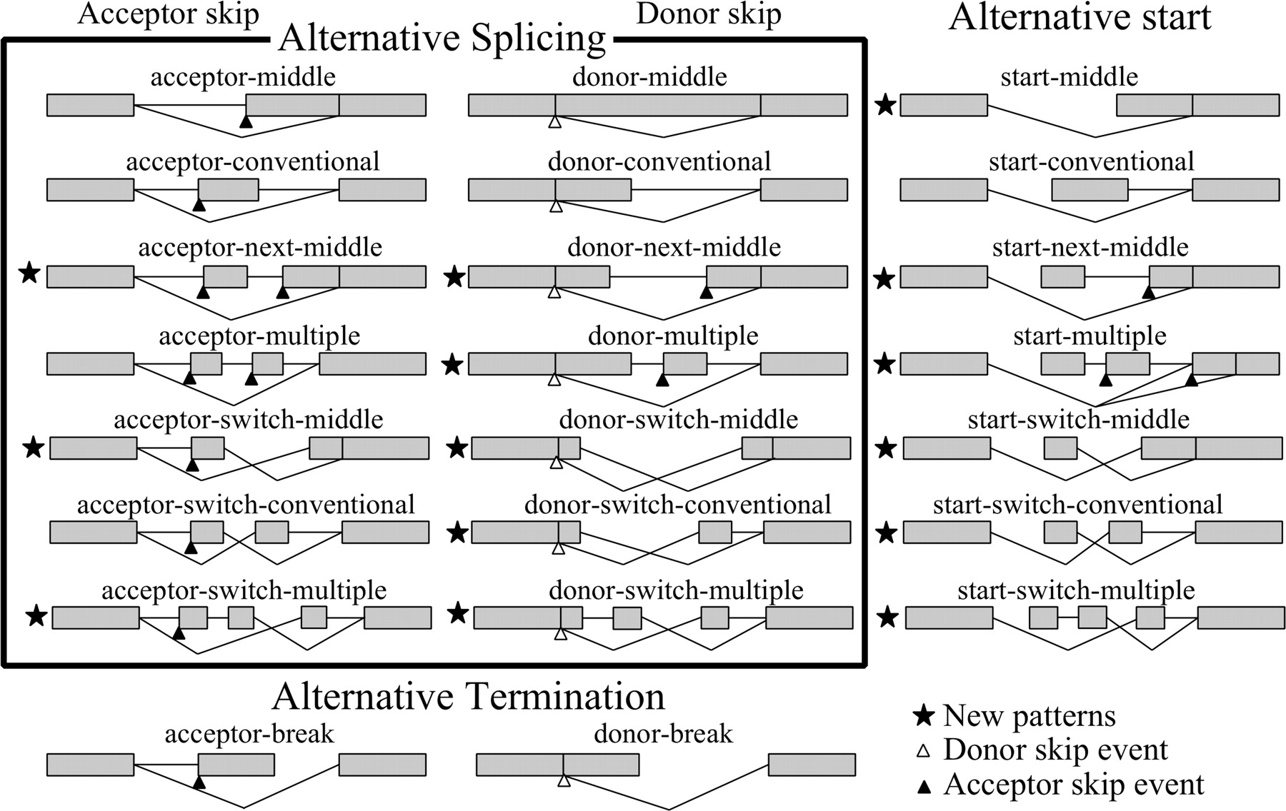

Combinatorial classification of ATS units.

Figure from A. Sharov et al. (http://www.genome.org/cgi/doi/10.1101/gr.3269805)